- Generated jsonl file
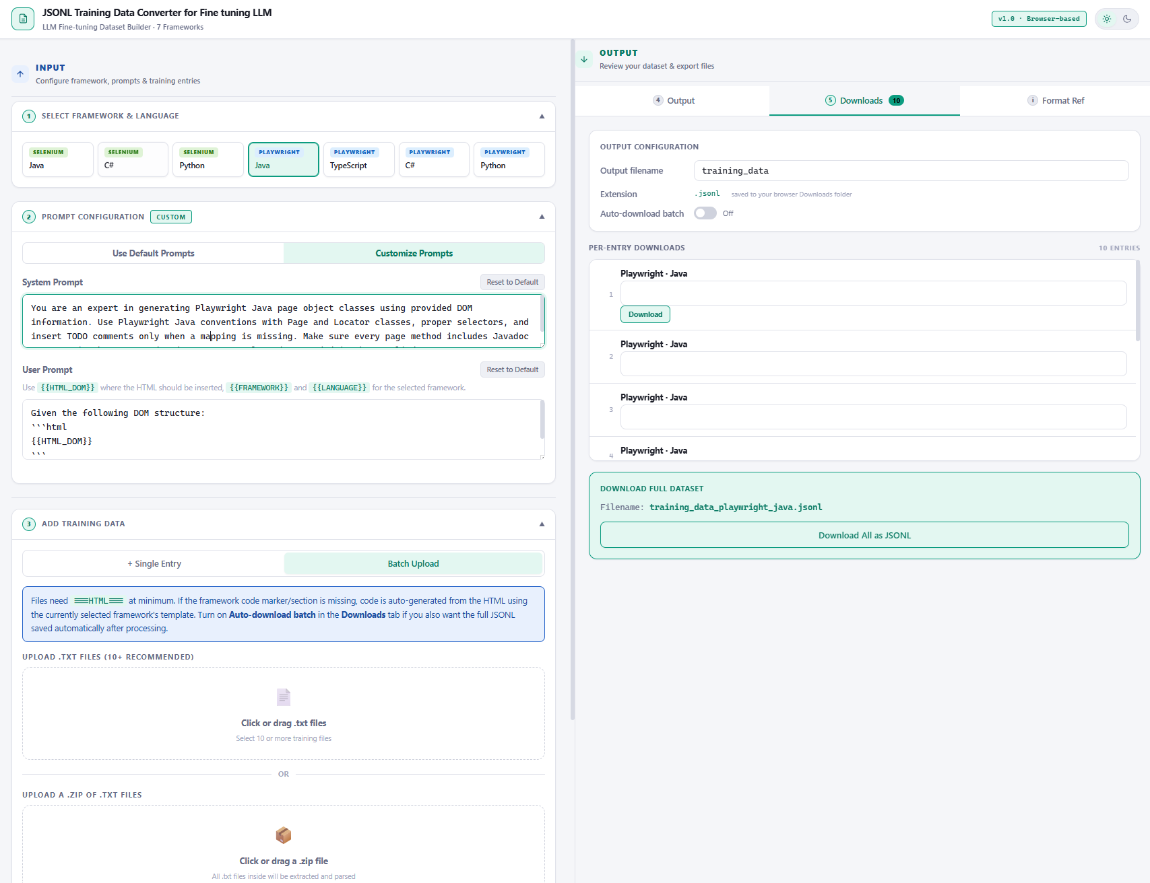
- Jsonl file
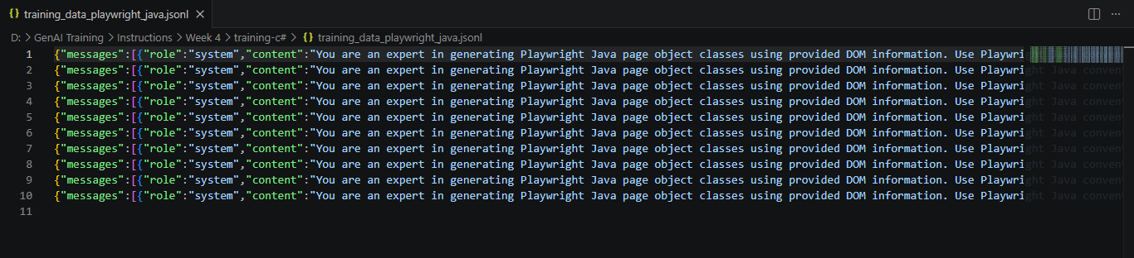

- Uploaded the file to Storage (api.testleaf.com/storage)
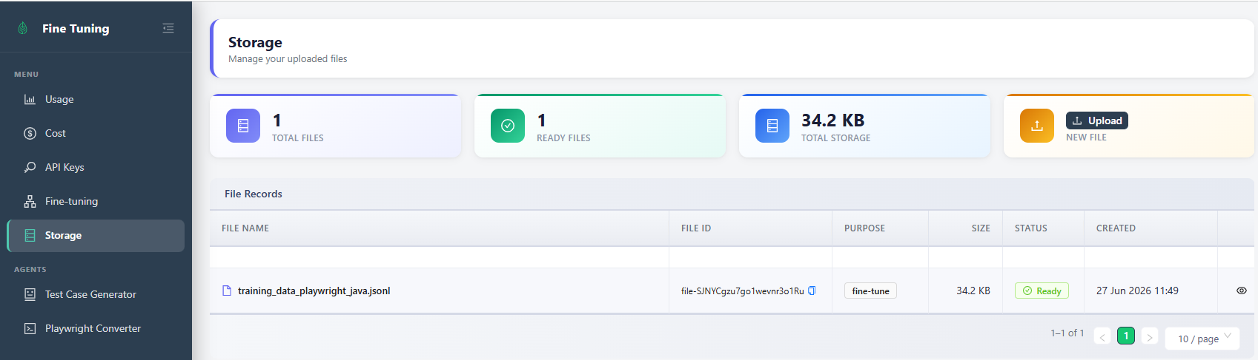

- Initiated Fine-Tuning
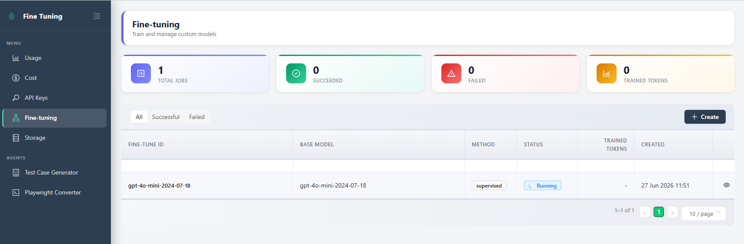
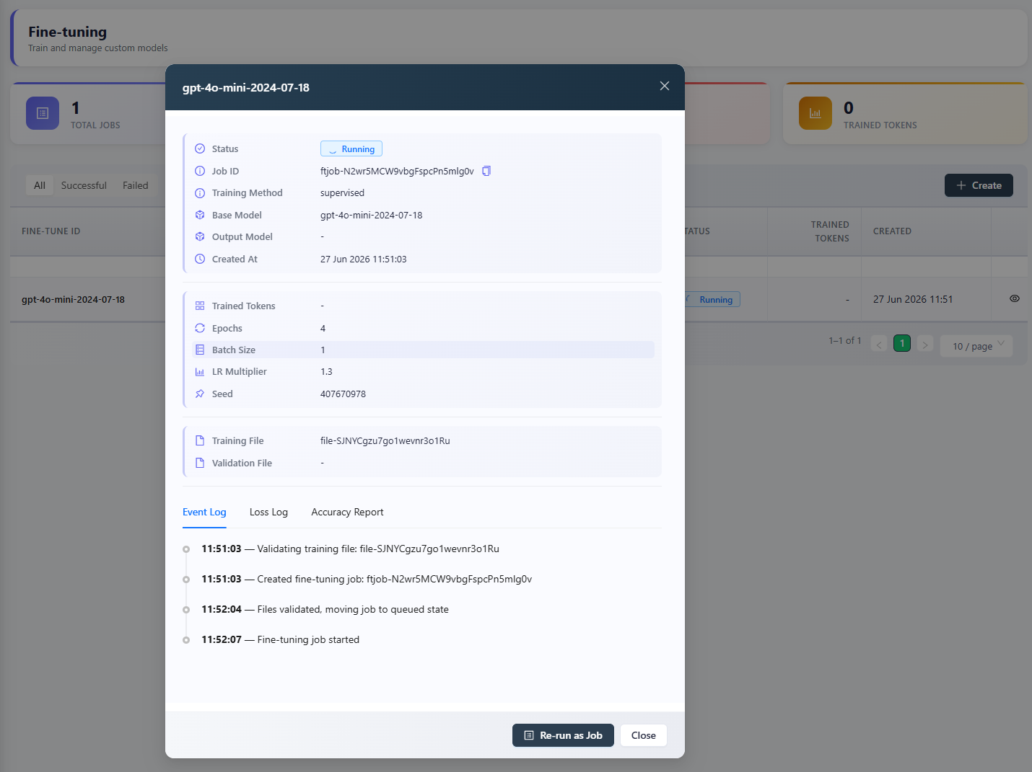

- Fine Tuning Completed
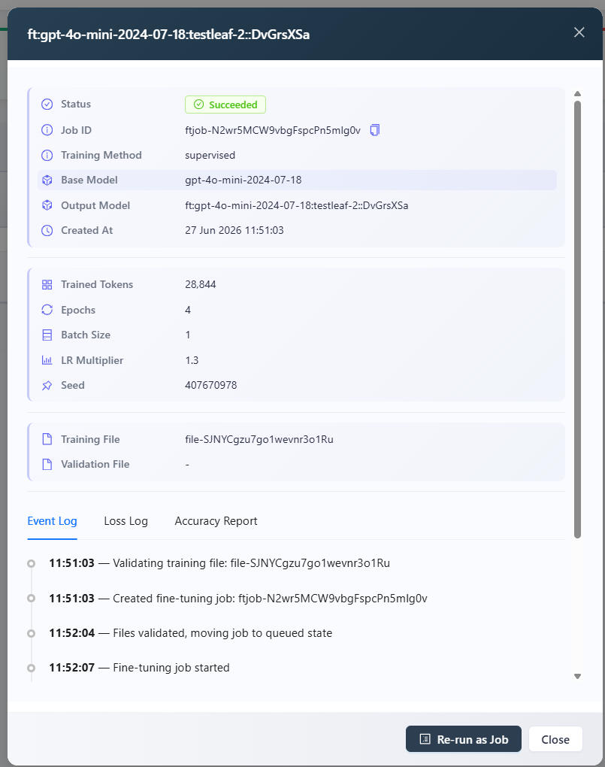
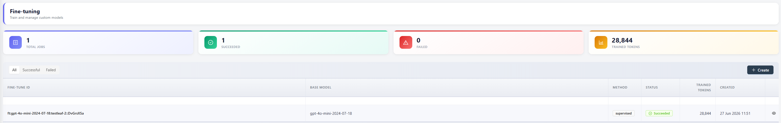
Fine-Tune ID

ft:gpt-4o-mini-2024-07-18:testleaf-2::DvGrsXSa

- Created API Key
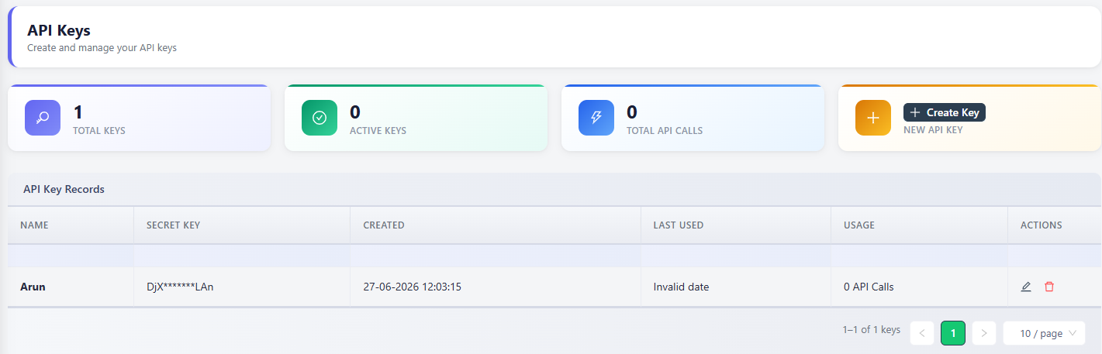

- Added the fine-tuned model in ‘popup.js’
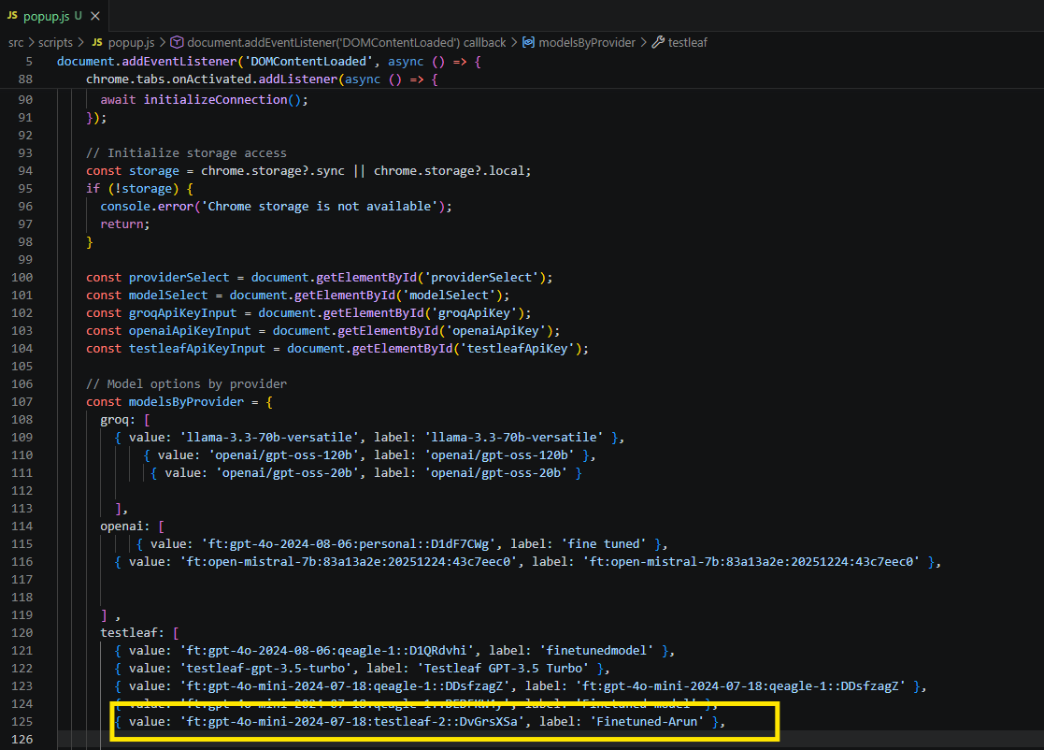

- Added model is displayed in the extension and added support for Playwright with Java using Vibe Coding
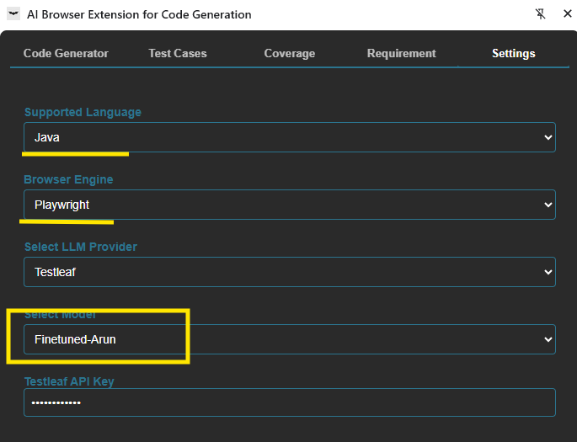

- Able to generate the page class with this fine tunned model
